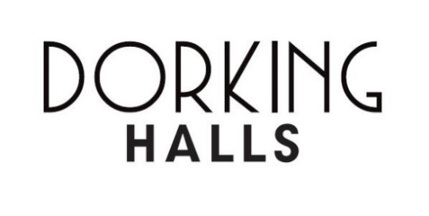**MVDC Internal Hire Agreement**

|  |  |
| --- | --- |
| **Department:** | **Event:** |
| **Event Date:** | **Event Time:** |
| **Room:** | **Resources:** |

**Hire Terms:**

1. Room hire charges are to be settled using an internal journal request form. The event is confirmed when both a signed MVDC Internal Hire Agreement has been received.
2. In the event of a cancellation, notice must be given in writing. If the event start date is more than two calendar months away, there will be no charge. Should there be less than two months, the agreed hire fee will be charged in full.
3. The deadline for confirming catering orders and technical requirements is two weeks prior to the event and these deadlines must be adhered to or catering may not be able to be supplied.
4. A MVDC representative must be present and prominent on the premises throughout the entire hire period until everyone connected to the event has left the building.
5. No advertisement or public announcement, including the inviting of attendees or selling tickets, for any event to be made prior to booking being confirmed.
6. Dorking Halls will provide all services, facilities and equipment as requested. Staff on duty, however, will respond in good faith to all reasonable requests for additional services or amendments to the original agreement. MVDC is responsible for any costs arising from such amendments or additions.
7. It is not permitted to use any glue, adhesive tape, pritt pads, nails or drawing pins to attach items to walls, pillars or fixtures. The full costs of making good any damages will be recharged. No extra stands, displays or equipment may be brought onto the premises without the prior consent of Dorking Halls.
8. MVDC shall be responsible for all items they bring into The Halls and those items shall be at the risk of MVDC. Dorking Halls accepts no responsibility for any items lost, stolen or damaged.
9. Sufficient Events Assistants shall be on duty at all times when the hire facilities are open to the public as well as a Duty Manager. In the event of an emergency, the Duty Manager will take control of the situation and required actions.
10. MVDC is not permitted to provide refreshments or catering in The Halls or to consume their own food and/or beverages without prior permission from Dorking Halls. Any food and/or beverages permitted, for which there may be a charge, must be not be consumed in the public areas of The Halls.

|  |  |  |  |
| --- | --- | --- | --- |
| Dorking Halls | Name: | Sign: | Date: |
| MVDC | Name: | Sign: | Date: |