**How to upload a photograph onto Teams & Office365**

We would like everybody to have a ‘selfie’ on their Teams profiles. This is in reflection of the Staff Survey 2022 where lots of you said you didn’t always know what people looked like; this is especially important for new starters. It is easy, and there are several ways to do it.

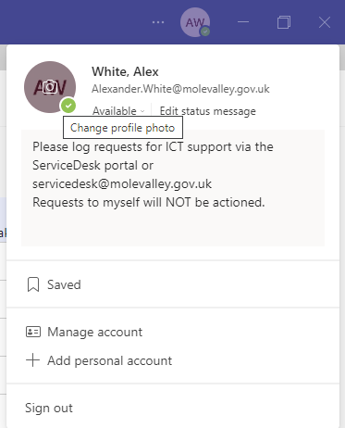Teams  
To add a photograph to Teams, click on your initials at the top right of the screen and then click the camera icon that appears when you hover over your initials in the pop-up box.

When you click on the camera icon, you will then be prompted to change the picture (or upload one for the first time).

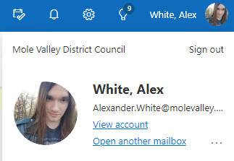Office 365

Alternatively, you can login to your Office 365 (Link under Top Tasks on Molly – or [quick link here](https://outlook.office365.com/mail/)).

Click on your name on the top right hand of the screen as per the example on the right:

Click on the thumbnail sketch and you can change or upload a new photograph.

**Note it may take a few days for a photo changed here to be visible on Teams (and vice versa).**

Photograph  
Please take a selfie using a mobile phone or whatever equipment you have to hand. Any of the common formats mobile phones use should be fine. You can then upload this to the Teams App if you have it installed on your phone or you can e-mail it to yourself and then upload it from there.

You can also use the “Camera” app that is installed on all the laptops. This will use the built in camera above the screen. That way the photo will be stored directly on the laptop, so it is easy to then upload it onto Teams. To do this:

1. A picture containing person, indoor, clothing, wall

   Description automatically generatedType ‘Camera’ into the search bar in the bottom right by the Start Menu.

1. Open the ‘Camera’ App
2. Take your photo by clicking the button on the right (See picture)
3. The photograph will be saved to the ‘Pictures’ folder on your laptop ready for you to upload.

Please make sure it’s appropriate to be used in an office context. If you’re happiest taking a shot on the beach or in a social setting, it’s fine providing we just see a headshot of you!

If you have any problems, please speak to your manager as they may have other team members that can help resolve things quickly. Alternatively you can log a call on the [Servicedesk](https://live.hornbill.com/mvdc/internal-lib/login/html/index.html?relayState=https%3A%2F%2Flive.hornbill.com%2Fmvdc%2Finternal%2Fhome%2F).

Privacy

This photograph is to accompany emails and Teams chats, it won’t be used for any other purpose but will be seen by all parties you are in a Teams call or Chat with (including external). Please see section 3.4 of the [Employers Privacy Notice](https://molevalleydc-my.sharepoint.com/personal/admin_molevalleydc_onmicrosoft_com/_layouts/15/onedrive.aspx?id=%2Fpersonal%2Fadmin%5Fmolevalleydc%5Fonmicrosoft%5Fcom%2FDocuments%2FMolly%2FUK%20GDPR%2FEmployers%20Privacy%20Notice%20UPDATED%20FOR%20CORONAVIRUS%20v%206%2020200610%2Epdf&parent=%2Fpersonal%2Fadmin%5Fmolevalleydc%5Fonmicrosoft%5Fcom%2FDocuments%2FMolly%2FUK%20GDPR) which includes processing of your image as potential personal data MVDC will collect or process. You are in control of your image and are at liberty to change it at any point however if you choose an image that is inappropriate or causes offence you will be asked to remove or change it.