**Putting a photograph on Teams**

We would like everybody to have a ‘selfie’ on their Teams profiles. This is in reflection of the Staff Survey 2022 where lots of you said you didn’t always know what people looked like; this is especially important for new starters. It is easy, and there are several ways to do it.

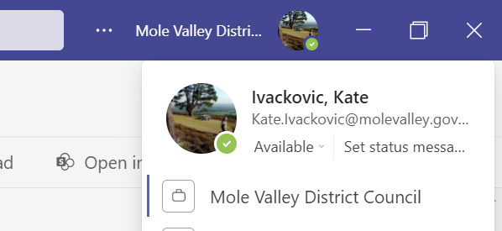Teams  
You can log into your Teams profile and click on the photograph to upload something from a file on your laptop.

In the example on the right if you click on the thumbnail picture of Mole Valley, you would then be prompted to change the picture (or upload one for the first time).

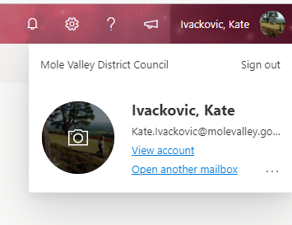Office 365 Alternatively, you can login to your Office 365 (Link under Top Tasks on Molly – or [quick link here](https://outlook.office365.com/mail/)).

Click on your name on the top right hand of the screen as per the example on the left:

Click on the thumbnail sketch and you can change or upload a new photograph.

**Note it may take a few days for a photo changed here to be visible on Teams (and vice versa).**

Photograph  
Please take a selfie using a mobile phone or whatever equipment you have to hand. Any of the common formats mobile phones use should be fine.

Please make sure it’s appropriate to be used in an office context. If you’re happiest taking a shot on the beach or in a social setting, it’s fine providing we just see a headshot of you!

If you don’t have access to a mobile phone or have any problems, please speak to your manager as they may have other team members that can help resolve things quickly. Alternatively you can log a call on the [Servicedesk](https://live.hornbill.com/mvdc/internal-lib/login/html/index.html?relayState=https%3A%2F%2Flive.hornbill.com%2Fmvdc%2Finternal%2Fhome%2F).

Privacy

This photograph is to accompany emails and Teams chats, it won’t be used for any other purpose but will be seen by all parties you are in a Teams call or Chat with (including external). Please see section 3.4 of the [Employers Privacy Notice](https://molevalleydc-my.sharepoint.com/personal/admin_molevalleydc_onmicrosoft_com/_layouts/15/onedrive.aspx?id=%2Fpersonal%2Fadmin%5Fmolevalleydc%5Fonmicrosoft%5Fcom%2FDocuments%2FMolly%2FUK%20GDPR%2FEmployers%20Privacy%20Notice%20UPDATED%20FOR%20CORONAVIRUS%20v%206%2020200610%2Epdf&parent=%2Fpersonal%2Fadmin%5Fmolevalleydc%5Fonmicrosoft%5Fcom%2FDocuments%2FMolly%2FUK%20GDPR) which includes processing of your image as potential personal data MVDC will collect or process. You are in control of your image and are at liberty to change it at any point however if you choose an image that is inappropriate or causes offence you will be asked to remove or change it.