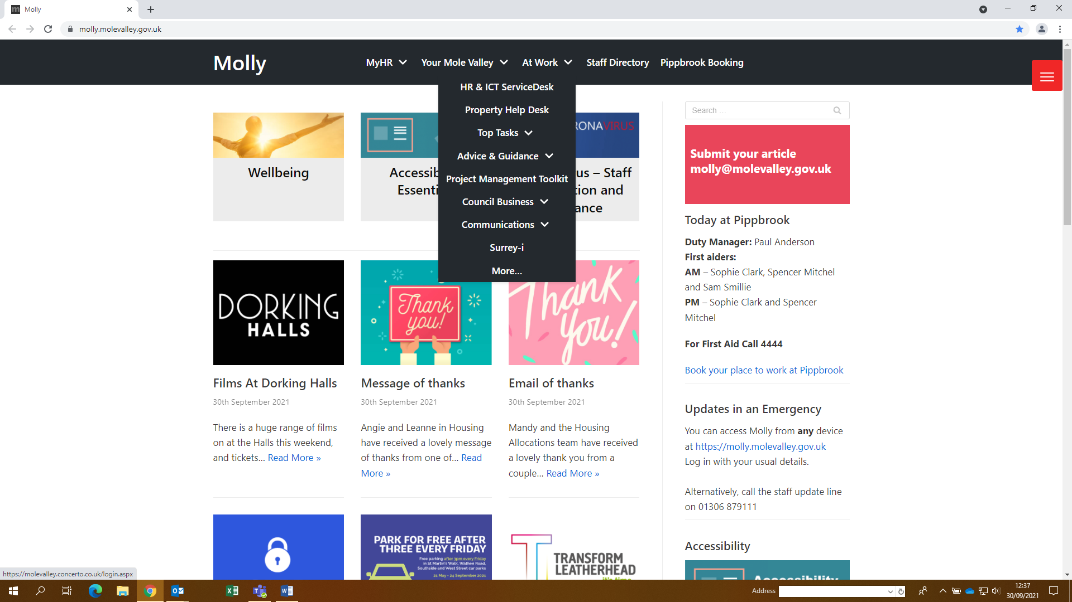How to Login to Concerto PROPERTY HELPDESK

Step 1 - Open up molly

Drop down list “At Work”

Then click Property Help Desk

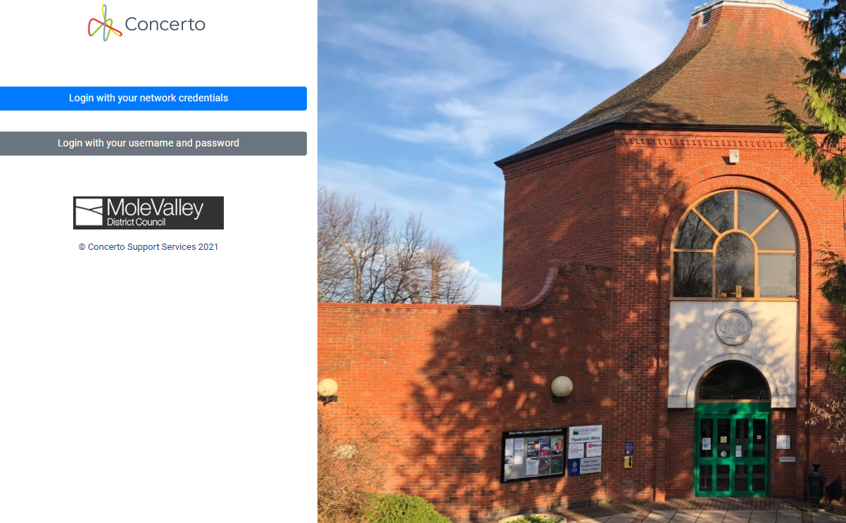

Step 2 - Click

“Login with your Network Credentials”

This has been set up automatically for you. If you are presented with an error screen please contact [Samantha.smillie@molevalley.gov.uk](mailto:Samantha.smillie@molevalley.gov.uk)

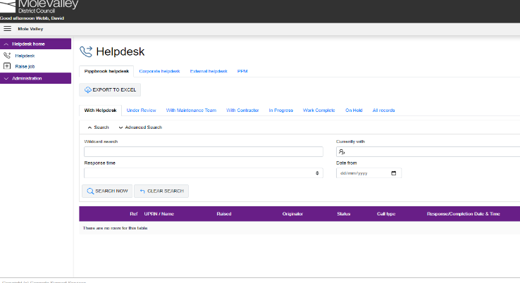

Step 3 - You will then be presented with your home page; this will differ depending on whether you are a Pippbrook profile or Corporate Landlord profile

This is where you can log and monitor any request you have made (this may be to request an item or report something is faulty)

Any jobs you have raised will appear under the long purple banner. You can see the progress of this and when it has been completed.

**Raising a Job**

Step 4 - On the top, right you will see + Raise Job

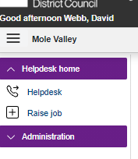

Step 5 - After clicking, “Raise a Job” search **Pippbrook** and press, “SEARCH NOW “

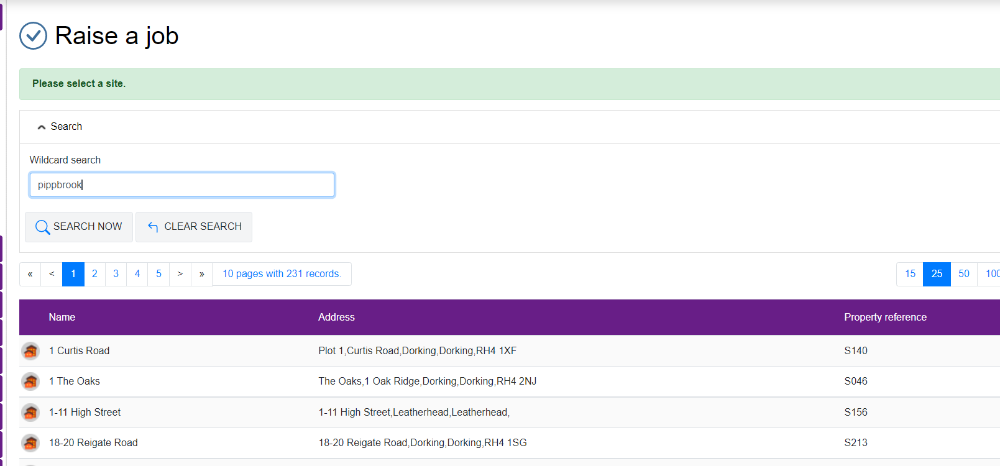

Step 6 - You can then see any jobs that have already been raised by others, if you can see that your request has been raised, for example “Pot hole near entrance”, then we are already aware and thankyou. If you have a different request please continue to next.

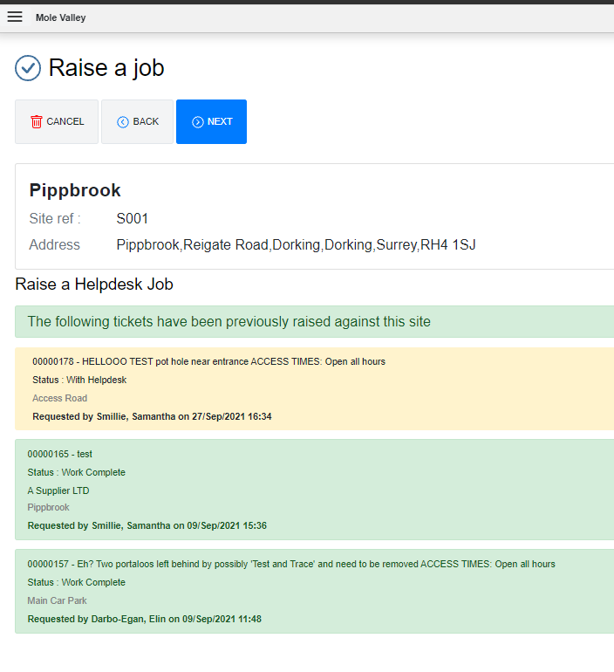

Step 7 - Below you will see three different help desks

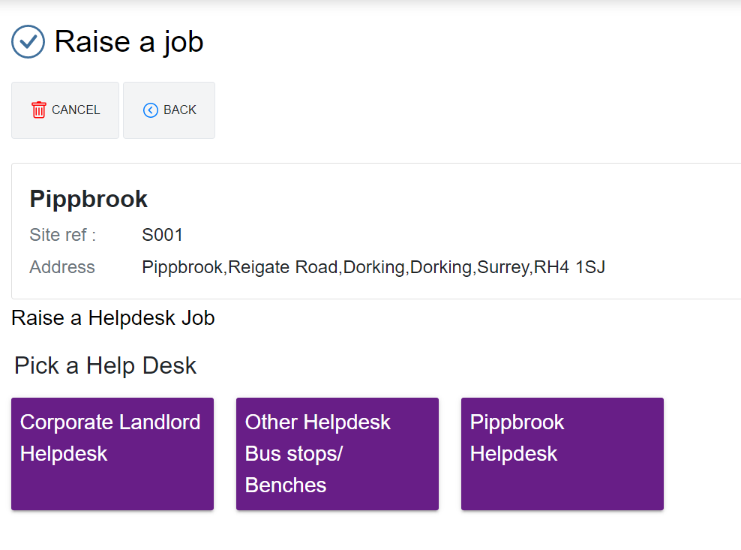

FOR PIPPBROOK USERS Please only use **Pippbrook Help Desk** - Pippbrook Request something or Fix something.

You will then be taken through a flow, please complete as best you can I have tried to keep this simple using free flowing text.

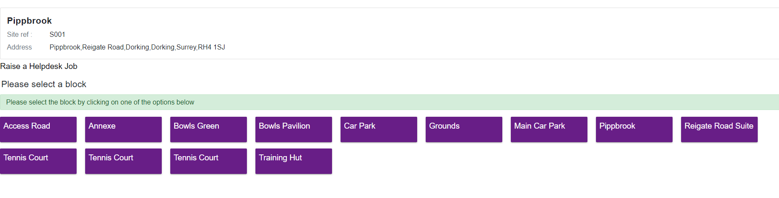**Example Request (planning support would like a foot rest)**

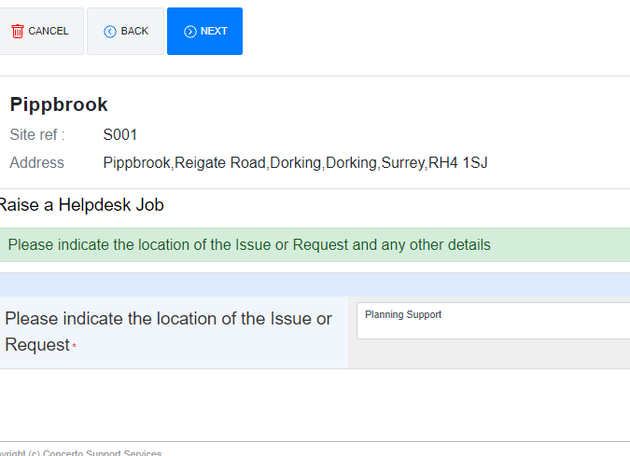

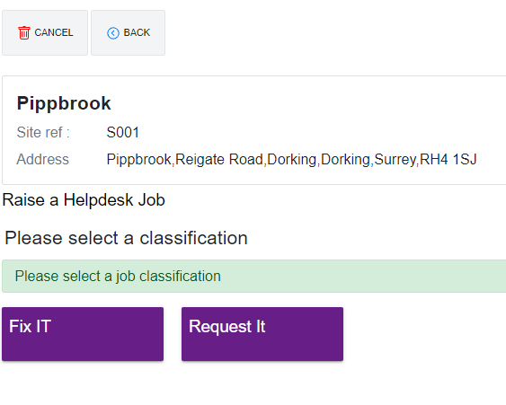

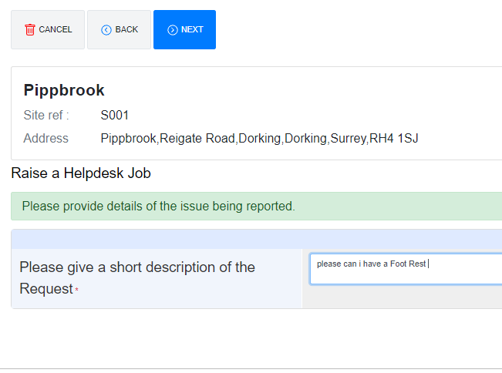

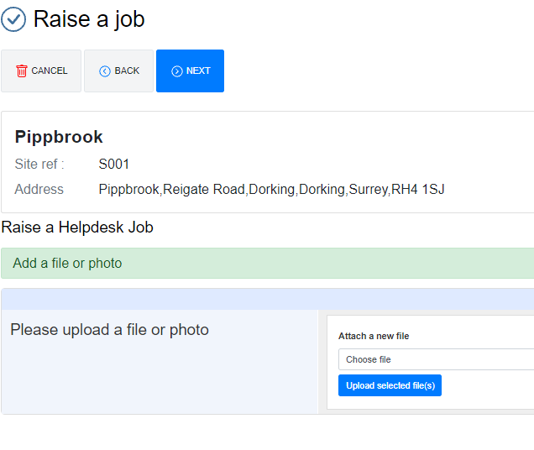

You have the choice to upload a photo, or continue to next.

**Please indicate if this is a health and safety issue**

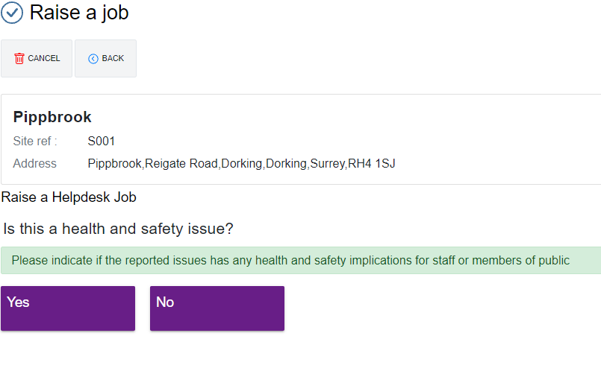

Below you will then see your summary then press complete

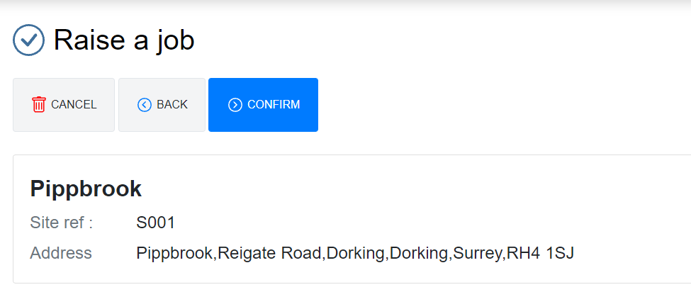

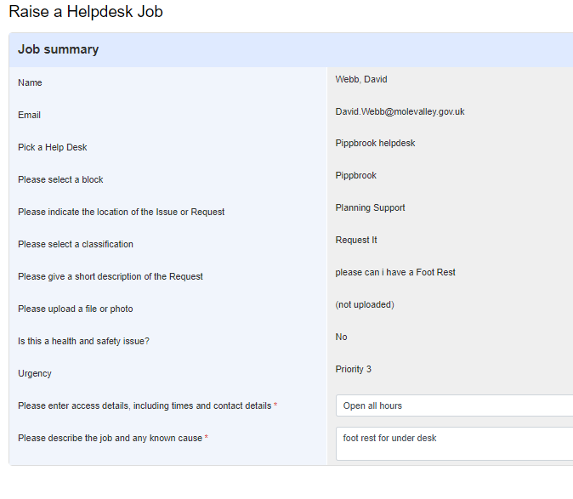

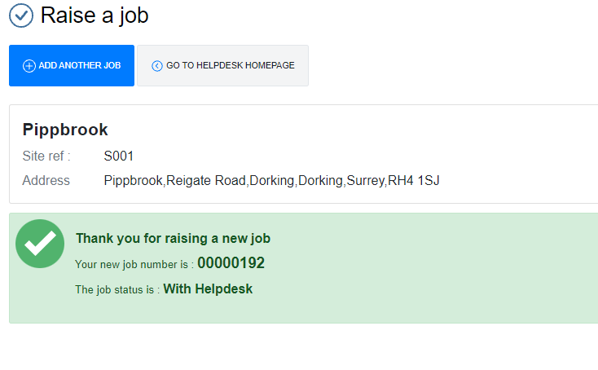

Go to Help Desk home page and you will see your logged request

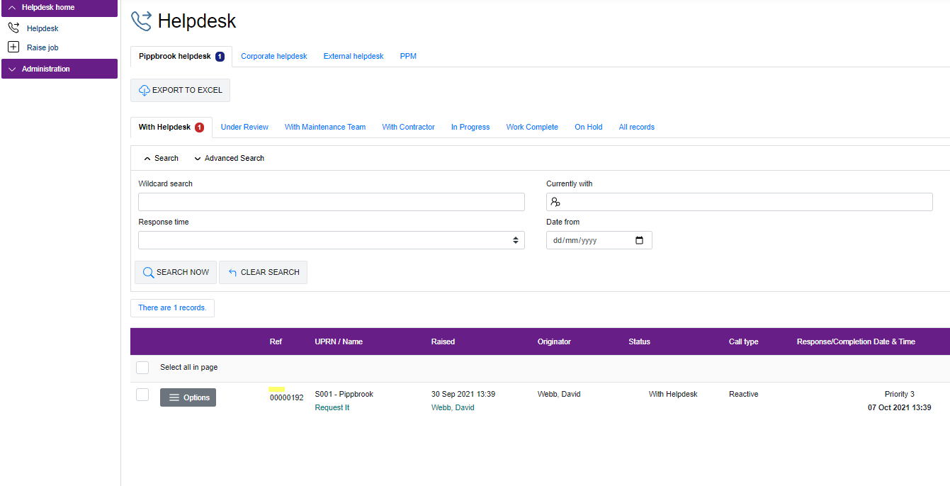

I hope this is clear for you – if you have any problems with using the Help Desk please contact:

[Samantha.smillie@molevalley.gov.uk](mailto:Samantha.smillie@molevalley.gov.uk) or [Property@molevalley.gov.uk](mailto:Property@molevalley.gov.uk)