**How to update your OS Maps in QGIS**

In the left pane of your QGIS desktop you should have a Layers panel that contains all the layers – maps, planning constraints, other information layers – that you use. Within this layer you will have some maps which make use of the current OS link:

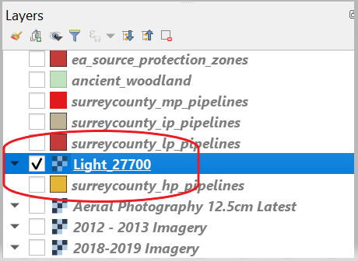

You should remove these by highlighting the layer and then selecting Remove/Layer Group.

In the left hand panel you should also see that you have a Browser window.

In this window you should see a menu titled WMS/WMTS. If you open up this drop down menu you should see a category titled OS Maps API:

If you do not have an OS Maps API under the WMS/WMTS go to page 4.

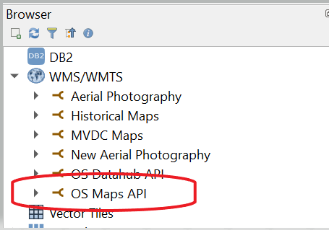

You should right click on this link and select ‘Edit……..’. A new window will open on your screen:

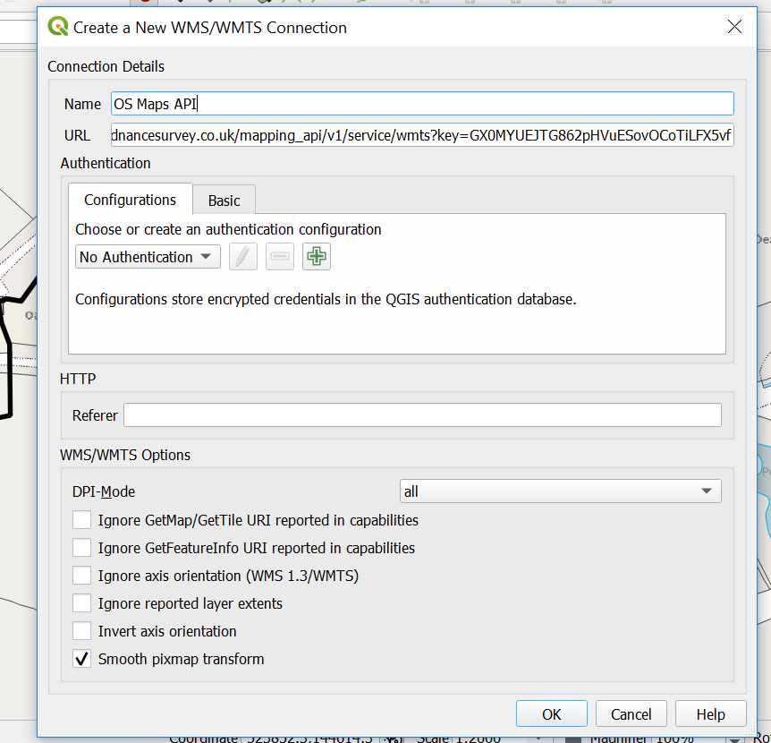

You should delete the URL and replace it with the following (make sure you do not miss off any letters otherwise it will not work):

<https://api.os.uk/maps/raster/v1/wmts?key=u01pDq4YV8Vx0UUL4Xt2CqzTkbwCpc4c>

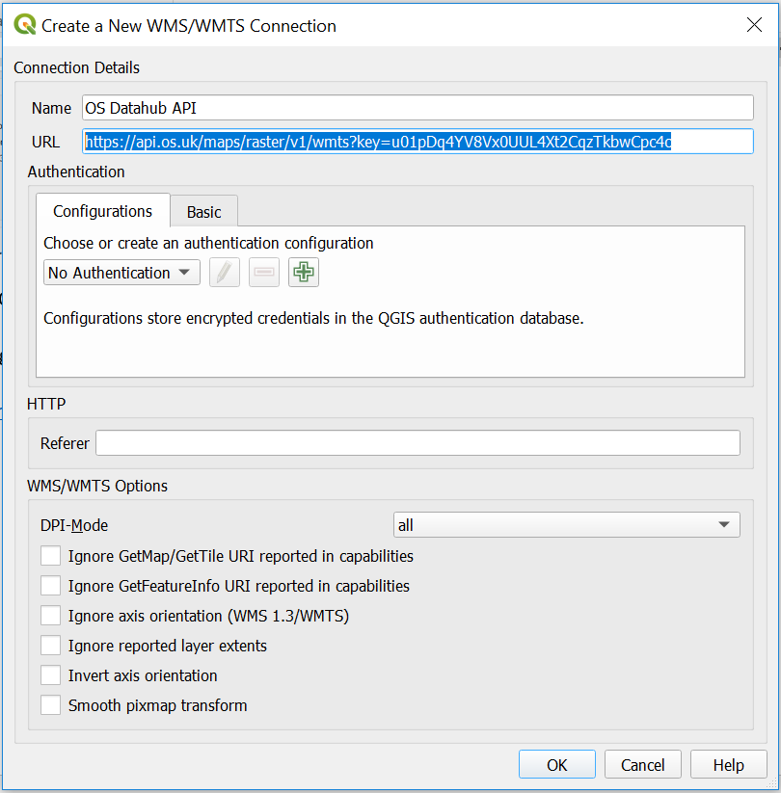

Then select OK

You should now Save your QGIS project. If you do not do this the link will not work.

You should now be able to open the OS Maps API menu and select your map by double clicking on your desired style. You should only select a layer with (27700)

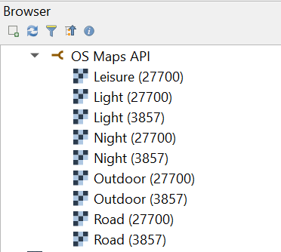

Make sure that the map is underneath all your layers otherwise it will obscure all the other information.

Once you have added your preferred style and moved the layer to the correct position make sure you Save your QGIS project again. [Please note that the Leisure style is not unlike the old OS paper maps and therefore does not work under about 1:10000 scale].

**The link that has been provided to you is not to be shared with any third parties as this has been given to us under a legal agreement with Ordnance Survey**

**How to add the OS Maps to QGIS**

On the left of your screen in QGIS you should have a Browser window in which there should be a link called WMS/WMTS:

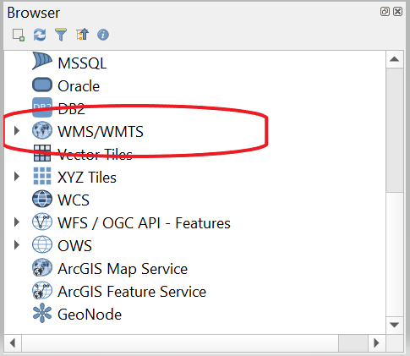

Right click in this link and Select ‘New Connection’. You should then have the following appear:

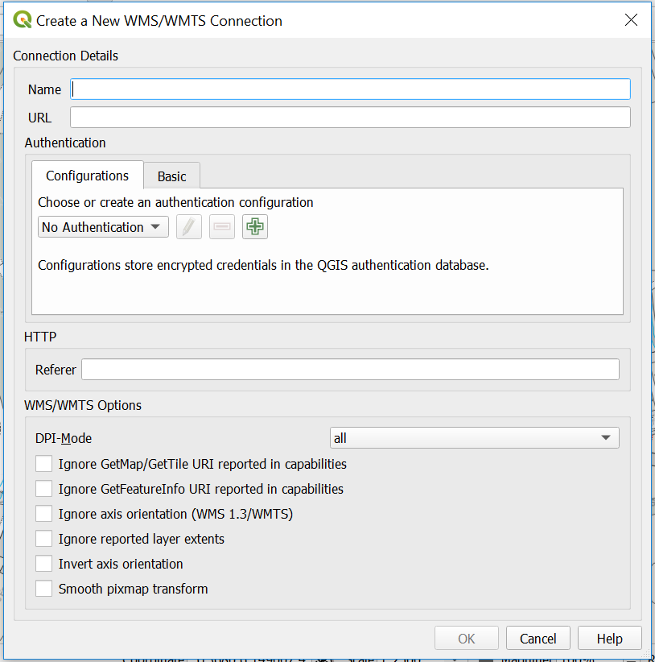

In the Name type OS Maps API or whatever you wish to call these maps.

Paste the following link into the URL:

<https://api.os.uk/maps/raster/v1/wmts?key=u01pDq4YV8Vx0UUL4Xt2CqzTkbwCpc4c>



You should then select OK and Save your QGIS project.

You should now be able to open the OS Maps API menu and select your map by double clicking on your desired style. You should only select a layer with (27700)



Make sure that the map is underneath all your layers otherwise it will obscure all the other information.

Once you have added your preferred style and moved the layer to the correct position make sure you Save your QGIS project again. [Please note that the Leisure style is not unlike the old OS paper maps and therefore does not work under about 1:10000 scale].

**The link that has been provided to you is not to be shared with any third parties as this has been given to us under a legal agreement with Ordnance Survey**