Title
Use this for the document title

Document Title

Table of Contents
This needs to be inserted using Word’s inbuilt automated Table of Contents block. Page numbering needs to be added into the page footer.

Table of Contents
Headings 2
Heading 1 2
Heading 2 2
Heading 3 2
Heading 2 with background 2
Heading 2 2
Paragraphs 2
Use of Tables 3
Bullets 3
Numbering 4
Columns and Breaks 4
Two Column Layout 4
Switching back to Single Column 4
Images 5
Shapes 5

Headings
Headings need to follow a logical order, so use Heading 1 first and heading 2 next and so on. You will then likely use heading 2 or 3 multiple times under one heading 1, this is called Nesting.

Heading 1

Heading 2

Heading 3

Heading 4

Heading 5

Heading 2 with background
A heading 2 with a background can be used to break up content

Heading 2

Paragraphs
Paragraph text is formatted as ‘Normal’ in text formatting
Lorem ipsum dolor sit amet, consectetur adipiscing elit, sed do eiusmod tempor incididunt ut labore et dolore magna aliqua. Ut enim ad minim veniam, quis nostrud exercitation ullamco laboris nisi ut aliquip ex ea commodo consequat. Duis aute irure dolor in reprehenderit in voluptate velit esse cillum dolore eu fugiat nulla pariatur. Excepteur sint occaecat cupidatat non proident, sunt in culpa qui officia deserunt mollit anim id est laborum.

Use of Tables
Table’s are used for presentation of data only. Table Headers are essential for all tables as they describe to a screen reader the data in each column or row. Tables must have an identical number of cells in each column or row to make them easy to navigate.
Table Headers at top
Table Header 1 | Table Header 2 | Table Header 3 | Table Header 3 | Table Header 5

Table Headers at side
Table Header 1
Table Header 2
Table Header 3
Table Header 4
Table Header 5

Table Headers Inverted
Table Header 1 | Table Header 2 | Table Header 3 | Table Header 3 | Table Header 5

Table Headers Side Inverted
Table Header 1
Table Header 2
Table Header 3
Table Header 4
Table Header 5

Bullets

- Bullet 1
- Bullet 2
- Bullet 3

Numbering

- Number 1
- Number 2
- Number 3

- 1 Use Shift to Move a level down

Columns and Breaks
Column layouts have to be done like this instead of tables.
Select the text you want to be formatted into columns, if you don’t do this the whole document will be formatted. Columns are accessed under Layout, choose how many you need.

Two Column Layout

Lorem ipsum dolor sit amet, consectetur adipiscing elit, sed do eiusmod tempor incididunt ut labore et dolore magna aliqua. Ut enim ad minim veniam, quis nostrud exercitation ullamco laboris nisi ut aliquip ex ea commodo consequat.

Duis aute irure dolor in reprehenderit in voluptate velit esse cillum dolore eu fugiat nulla pariatur. Excepteur sint occaecat cupidatanon proident, sunt in culpa qui officia deserunt mollit anim id est laborum.

sed do eiusmod tempor incididunt ut labore et dolore magna aliqua. Ut enim ad minim veniam, quis nostrud exercitation ullamco laboris nisi ut aliquip ex ea commodo consequat.

Excepteur sint occaecat cupidatanon proident, sunt in culpa qui officia deserunt mollit anim id est laborum.

Switching back to Single Column
Under Layout select Breaks > Continuous Break
Then select Columns > One

Lorem ipsum dolor sit amet, consectetur adipiscing elit, sed do eiusmod tempor incididunt ut labore et dolore magna aliqua. Ut enim ad minim veniam, quis nostrud exercitation ullamco laboris nisi ut aliquip ex ea commodo consequat. Duis aute irure dolor in reprehenderit in voluptate velit esse cillum dolore eu fugiat nulla pariatur. Excepteur sint occaecat cupidatat non proident, sunt in culpa qui officia deserunt mollit anim id est laborum.

Images
It’s fine to use images, they just need ‘Alternative Text’ or a caption to describe what they are.
In the example below the alt text might be “Percentage of animals in Mole Valley – 25% Dogs, 46% Cats, 21% Fish and 8% Hamsters”

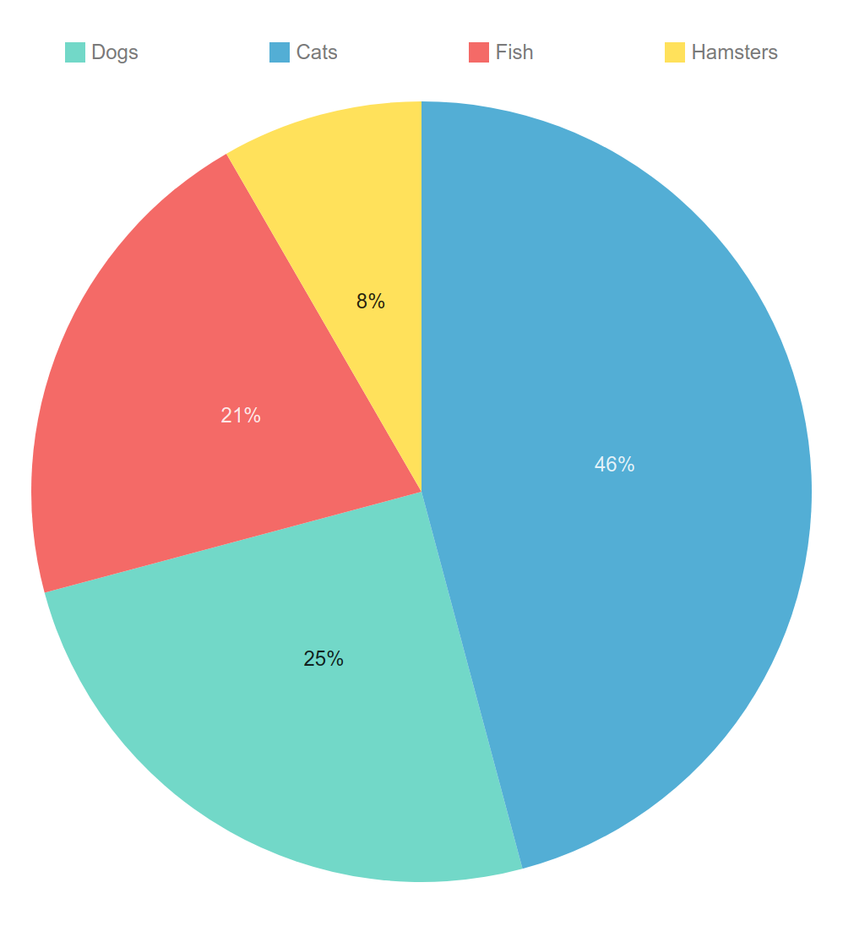

Shapes
Shapes can be used for flowcharts and diagrams but every element requires its own alt text and that includes arrows and lines

